**CAPSTONE PROJECT**

**ONLINE SALON SERVICE APPLICATION**

**BATCH-8**

**JAVA J2EE**

**Name: SHANIGARAPU YUGENDER**

**Email:** [**bunnyyugender@gmail.com**](mailto:bunnyyugender@gmail.com)

**Date: September 2, 2024**

**Trainer: Ramakrishna (RK)**

**Contents.**

1. **Introduction**
2. **Skill Description**
3. **Project Flow**
4. **Problem Statement**
5. **Microservices Architecture**
6. **Admin Module**
7. **User Module**
8. **Testing and Refinement**
9. **Conclusion**

**1.Introduction**

The Online Salon Service Application is a distributed system built using Spring Microservices to manage and book salon services efficiently. It provides separate modules for administrators and users, enabling admins to manage services, staff, bookings, and customer data, while allowing users to browse services, book appointments, and manage their bookings.

The application uses a microservices architecture, ensuring scalability and flexibility, with components like a service registry, API gateway, and specialized microservices for each core functionality. This system is designed to streamline salon operations and enhance the overall customer experience.

**2. Skill Description**

**Technologies Used:**

* + **Java:** Core programming language.
  + **Spring Boot**: Framework for building microservices.
  + **Spring Cloud:** Suite of tools for managing microservices.
  + **Spring Data JPA:** For database interactions.
  + **MySQL/MariaDB**: Relational database management systems.
  + **RESTful APIs**: For communication between services.

**3. Project Flow**

**4. Problem Statement**

Objective:

**Admin:**

* Manage salon services, including adding, editing, and deleting offerings.
* Oversee staff, including assigning them to specific services.
* Handle bookings by viewing, modifying, or canceling appointments.
* Manage customer information and booking histories.

**Users:**

* Browse and view available salon services.
* Book appointments by selecting preferred services, dates, times, and staff.
* Manage their bookings, including modifying or canceling appointments

**5. Microservice Architecture**

The application is divided into several microservices, each responsible for a specific aspect of the system.

**5.1 Service Registry & Discovery**

**Eureka Server:**

* + A centralized service registry where all microservices register themselves.
  + Enables dynamic discovery of services, allowing them to find and communicate with each other without hard-coded URLs.

**5.2 API Gateway**

**Spring Cloud Gateway**:

* + Acts as the entry point for all client requests.
  + Routes requests to the appropriate microservice based on the request path.
  + Provides cross-cutting concerns like security, rate limiting, and logging.

**5.3 Authentication Service**

**User Authentication & Authorization:**

* + Manages user registration, login, and JWT token generation.
  + Handles roles for Admin and User to secure access to different parts of the application

**5.4 Service Management Microservice**

**Service Catalog**

* + Responsible for managing salon services.
  + Exposes APIs for adding, editing, deleting, and fetching services.
  + Uses Spring Data JPA for database interactions.

**5.5 Staff Management Microservice**

**Staff Directory:**

* + Manages staff members and their assignments to specific services.
  + Includes APIs for adding, editing, deleting, and viewing staff details.

**5.6 Booking Management Microservice**

**Appointment Scheduling**

* + Handles the creation, modification, and cancellation of bookings.
  + Ensures validation to prevent double booking of staff members.
  + Manages booking status (e.g., pending, confirmed, completed, canceled).

**5.7 Customer Management Microservice**

**Customer Profiles**

* + Manages customer information and booking history.
  + Provides APIs for customer profile management and viewing booking history.

**6. Admin Module**

**Admin Dashboard:**

* A consolidated view of all operations handled by the Admin.
* Provides access to manage services, staff, bookings, and customers.

**Service Management**:

* Admin can perform CRUD (Create, Read, Update, Delete) operations on salon services through the Service Management Microservice.

**Staff Management**:

* Admin can manage staff information and their service assignments through the Staff Management Microservice.

**Booking Management**:

* Admin can monitor and modify bookings through the Booking Management Microservice.
* Admin can reassign staff to bookings and update booking statuses.

**Customer Management**:

* Admin can view and manage customer profiles and booking history.

**7. User Module**

**User Registration & Authentication**:

* Users can register and log in using the Authentication Service.
* JWT tokens are used to secure API access.

**Service Browsing**:

* Users can browse available salon services through the Service Management Microservice.

**Appointment Booking**:

* Users can book appointments, specifying their preferred service, date, time, and staff.
* The Booking Management Microservice ensures that the booking is valid and that staff are available.

**Booking Management**:

* Users can view, modify, or cancel their appointments via the Booking Management Microservice.
* Notifications are sent for booking confirmations and reminders.

**8.Testing and Refinement**

**Junit**

Authentication

Booking-service

Customer-service

Service

Staff-Service

**Running the Application as SpringbootApp:**



**Data Base MySQL Workbench:**

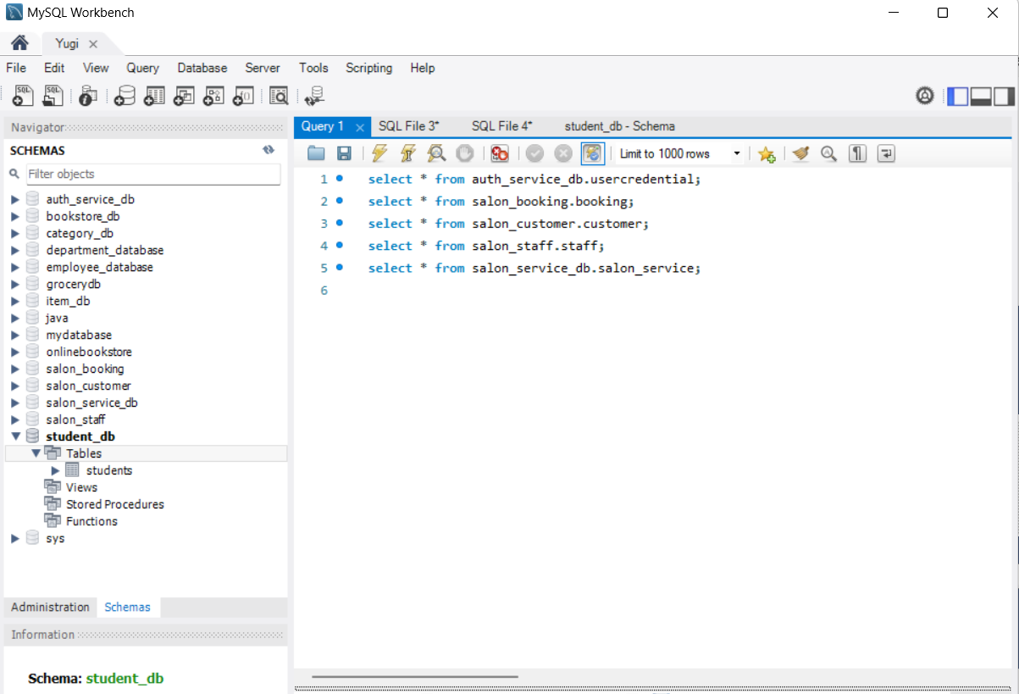

**Viewing tables in MySQL:**

**Eureka DashBoard:**

PostMan

Authentication

For Register

For Token Generation

For Token Validation

**Service**

Staff

Booking

Customer

Conclusion

* Developed a distributed Online Salon Service application using Spring Microservices.
* Created a robust admin module for managing services, staff, bookings, and customers.
* Provided a user-friendly interface for customers to browse and book services.
* Achieved seamless integration and communication between microservices.
* Implemented secure JWT-based authentication for admins and users.
* Built a scalable architecture for easy addition of new features.
* Conducted thorough unit and integration testing to ensure reliability.

Thank you